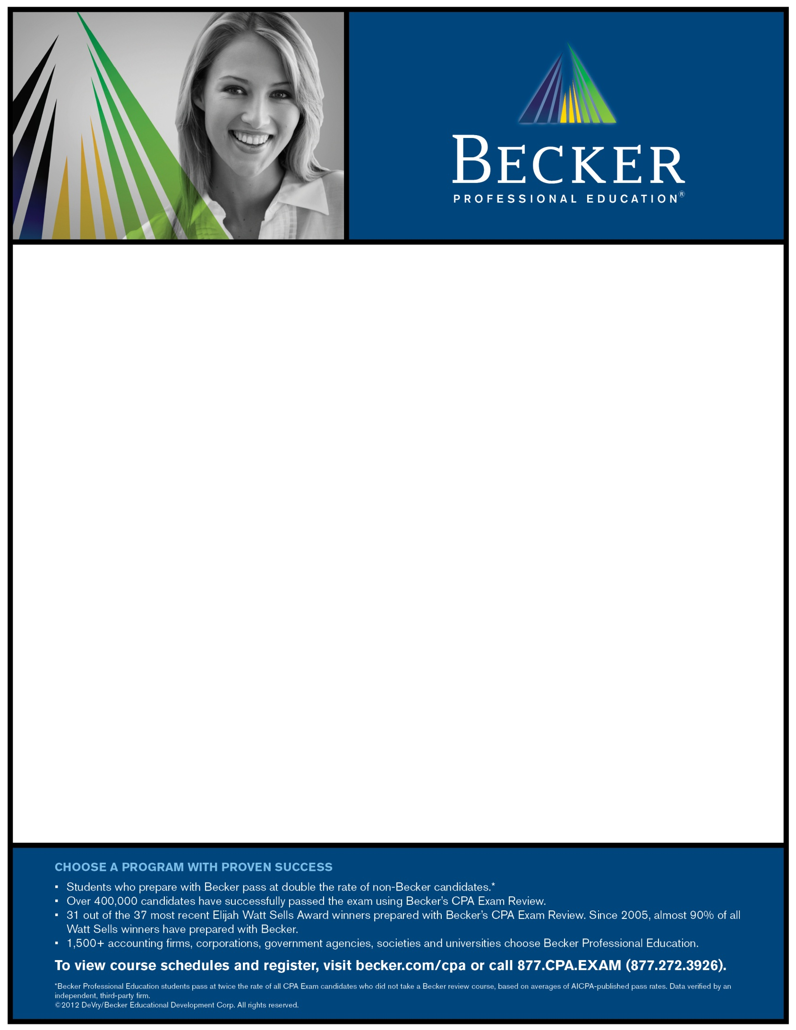

Live Study Hall Sessions

For Oregon State Online Fast Pass Course

Summer 2013

9:00 AM-1:00 PM

DeVry University – Room 215

Saturday, June 22

Saturday, June 29

Saturday, July 13

Saturday, July 20

Saturday, July 27

Saturday, August 3

Saturday, August 17

Saturday, August 24