

**Achieve your CPA goals in 2013 - Enroll in Becker Professional Education's Online FastPass® Class Exclusively for Oregon State Students!**

Prepare for the CPA Exam in a matter of weeks instead of months with Becker's FastPass! This accelerated class contains the same content as our standard CPA Exam Review program but equips you for the exam in a fraction of the time. Get ready to jump-start your accounting career!

Enroll in Becker's FastPass course and take advantage of 0% Financing. Visit [becker.com/financing](http://becker.com/accounting/cpaexamreview/financing/?utm_source=RER_ALL_FY13&utm_medium=email_RER_ALL_FY13&utm_content=bodyLink_RER_ALL_FY13&utm_campaign=RER_ALL_FY13) to learn more.

**2013 Oregon State University FastPass Class Online Schedule**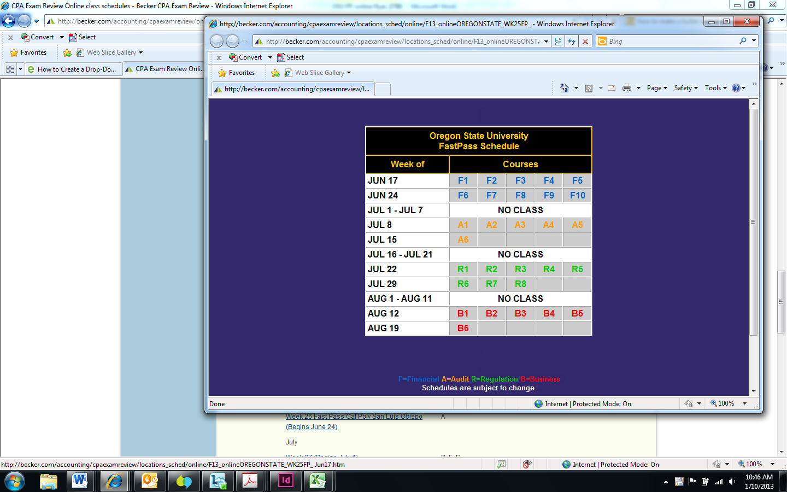

F=Financial A=Audit R=Regulation B=Business **Schedules are subject to change**. **Each week of the section, there will be a LIVE Study Hall session in Portland**

For more information or to enroll, visit becker.com/cpa ,Search **Online Course Schedules Week 25** Fast Pass Oregon State University or contact Lois Moll at lmoll@becker.com.  
  
[Live and Self-study formats](http://becker.com/accounting/cpaexamreview/courses/CPA-Review/Flexible-Formats/index.cfm) are also available.