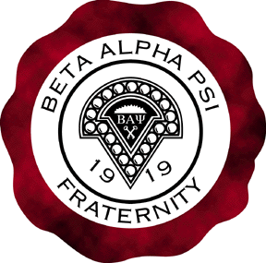
College of Business

Oregon State University

200 Bexell Hall
Corvallis, Oregon 97331

Beta Alpha Psi

Epsilon Chapter

January 20, 2014

Dear Accounting Seniors of the Class of 2014,

CONGRATULATIONS! You’ve made it two thirds of the way through our senior year. While we hope everyone is avoiding senioritis and surviving midterms, there are a few more tasks you need to add to your ‘to-do’ lists!

Please make sure to call and make an appointment to have your Senior Composite picture taken! The Ball Studio has offered to take pictures for FREE of Accounting Graduates! Having a ‘Class of 2014’ Composite hanging in the new business building will really mean a lot to the Accounting Professors. The deadline for pictures is May 15th, 2014 so please make your appointment early! www.theballstudio.com theballstudio@gmail.com (541) 753-5721

Let’s celebrate your achievements in style at the Accounting Graduation Banquet! This year it will be held on Wednesday, May 14th 2014 at 5:30pm in the CH2M Hill Alumni Center. Any accounting student graduating in 2014 is welcome to attend! Why not let the Accounting Faculty honor you guys! Please RSVP to me at Matt Little littlem@onid.orst.edu if you will be able to attend!

Beta Alpha Psi Senior Members- Please make sure you complete the minimum drop-in tutoring hours and community service hours required to maintain membership and earn your cord!

All the best,

Beta Alpha Psi Officers and the Accounting Faculty

